**Perform Man in the Middle Attack**

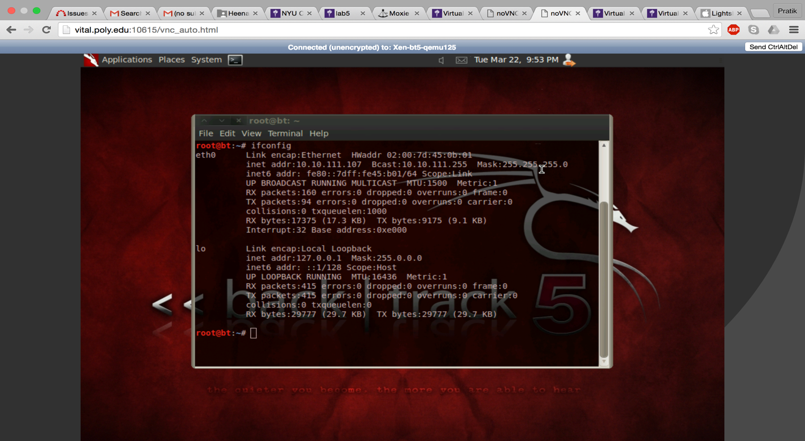

Since SSLStrip works on domain names, we will modify the external router machine so that it can serve as a DNS server and properly resolve the name.

In file /etc/bind/db.vlab.local we replace fakebook IN A xxx.xxx.xxx.xxx with fakebook IN A 10.12.1.10

Appended line nameserver 10.10.111.1 in file /etc/resolv.conf

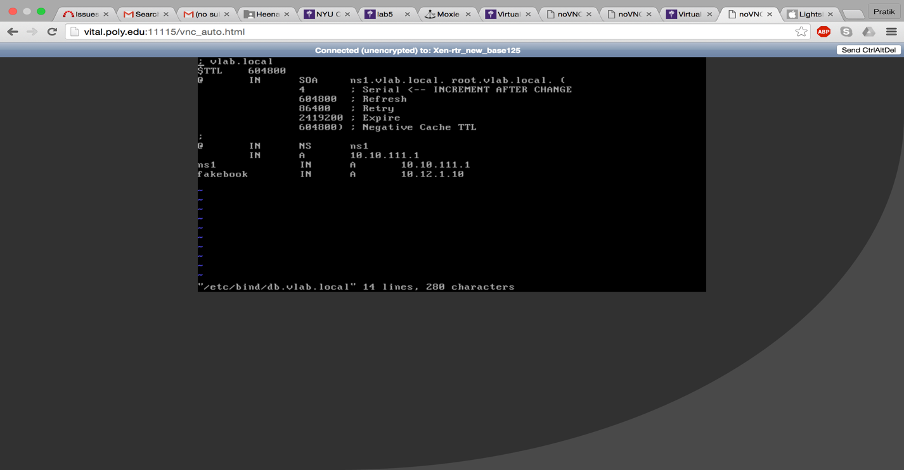

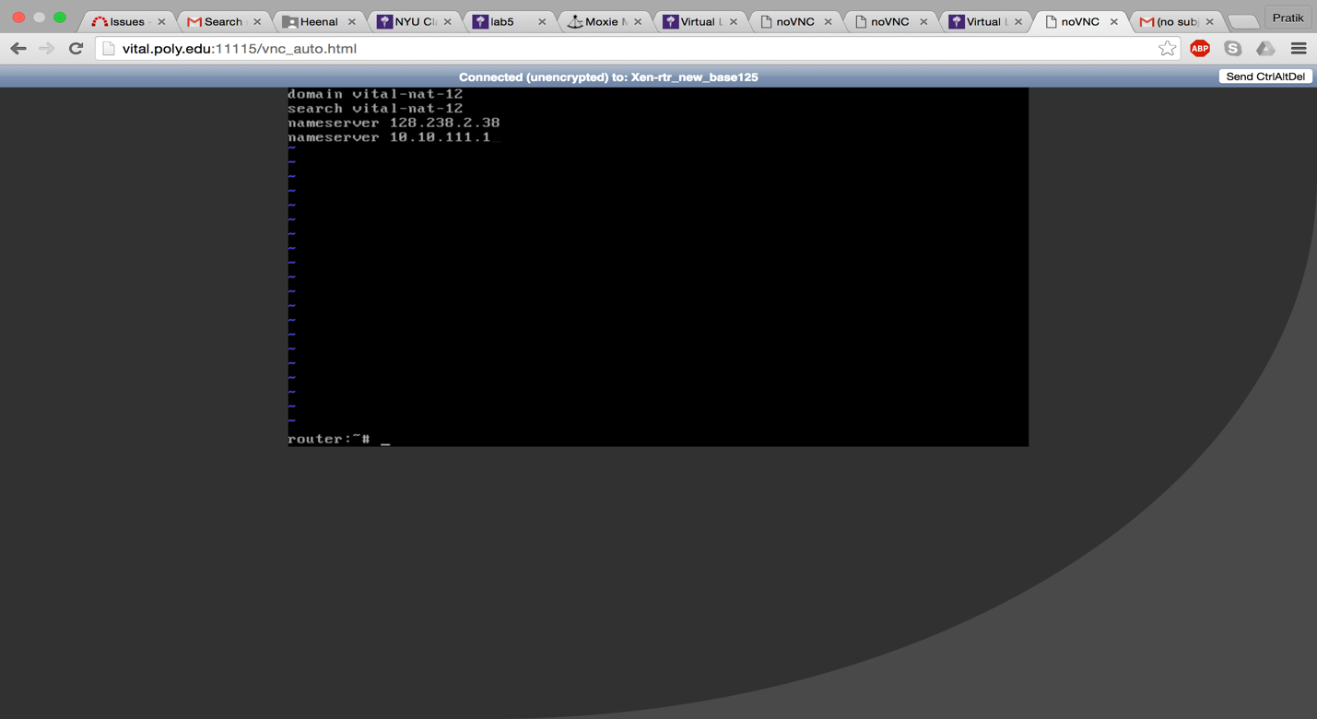

Now open the Firefox browser from client machine (Windows XP) and click “view page source”

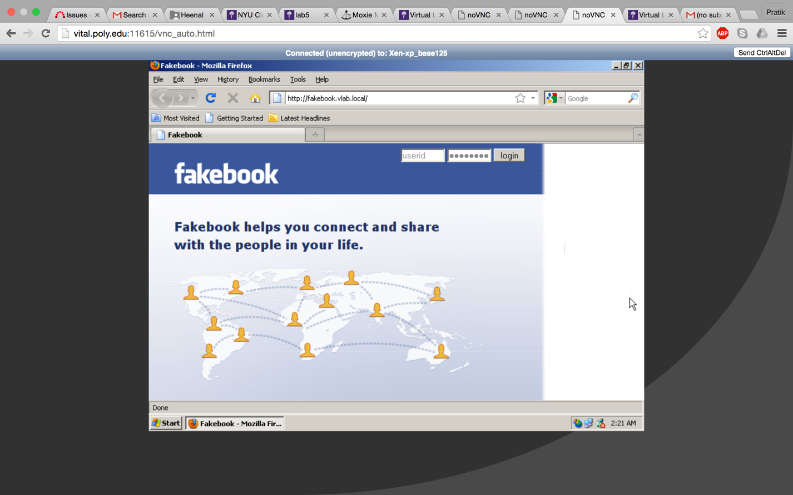

We can see it is https in form actions.

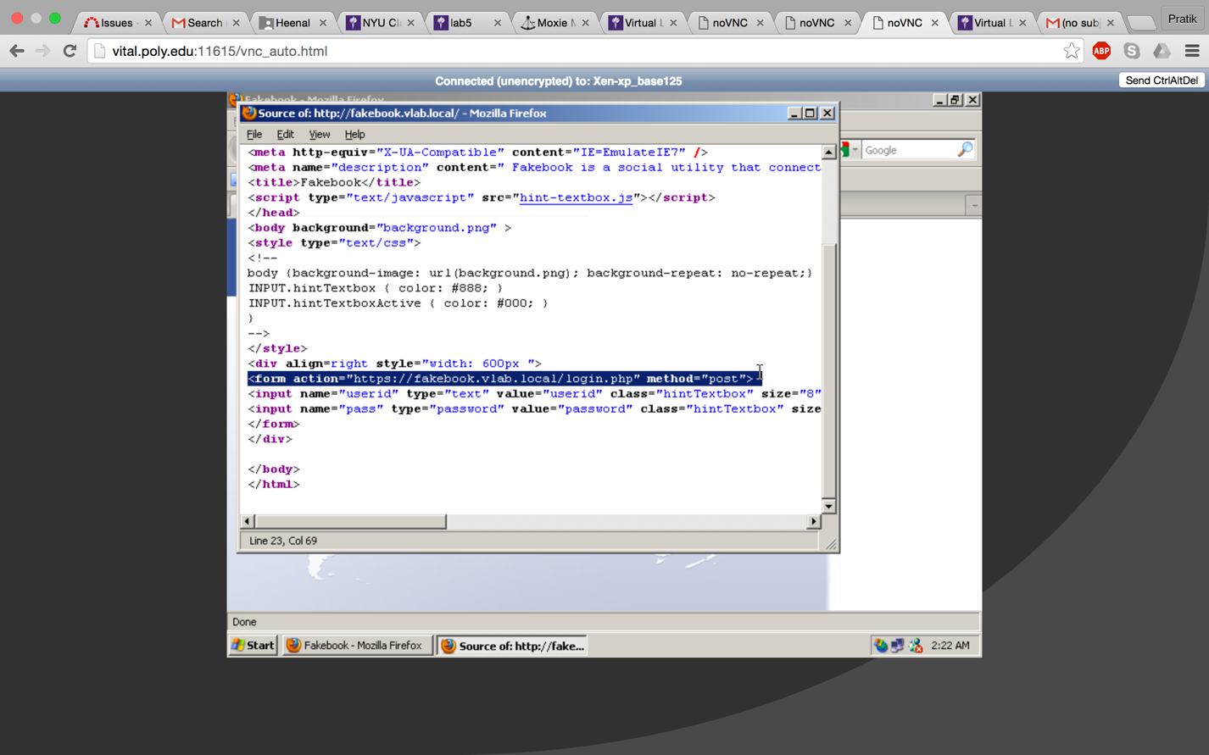

Make sure that the Backtrack5 machine has an ip address and that the default gateway is pointed at the 10.10.111.1. Use command netstat –rn to check.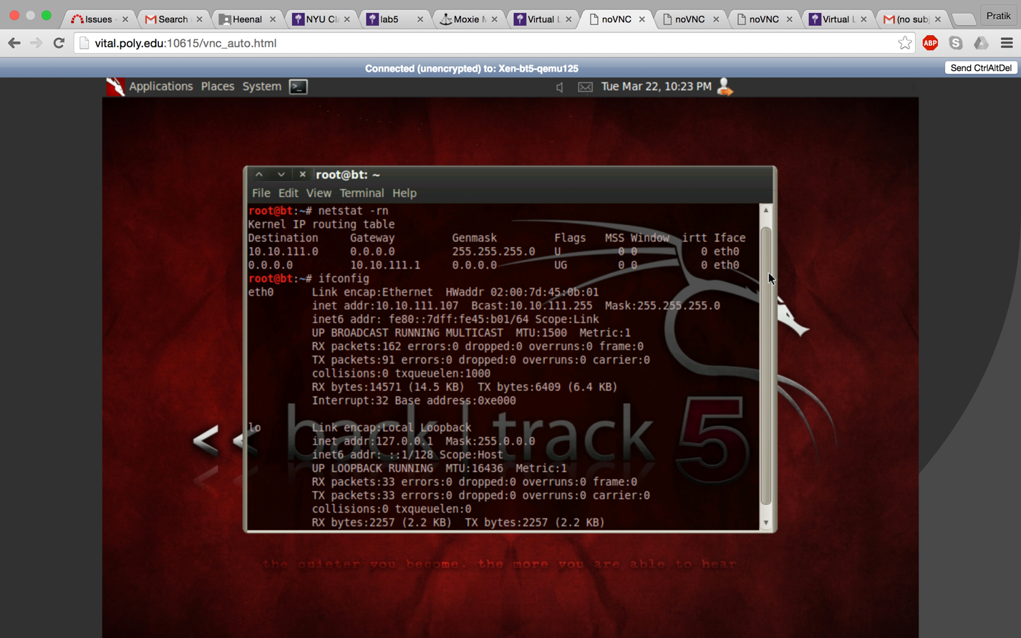

In order to use arpspoof we will need the ip address in the victim. This can done using Nmap from the Backtrack5 machine. Use command: **nmap –sV –O 10.10.111.0/24**

Address is: 10.10.111.110

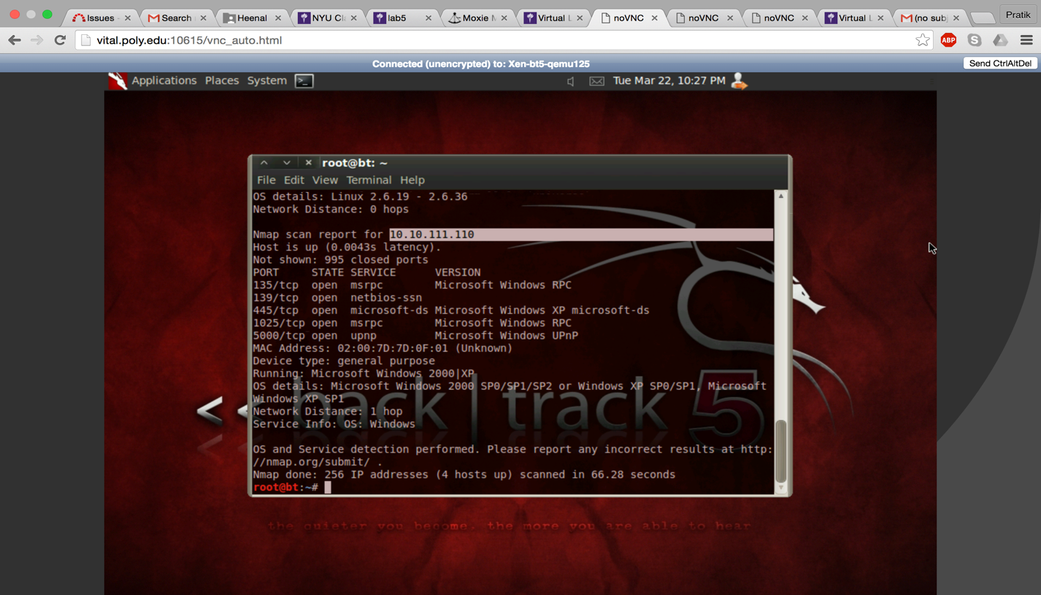

Arp cache before arpspoofing.

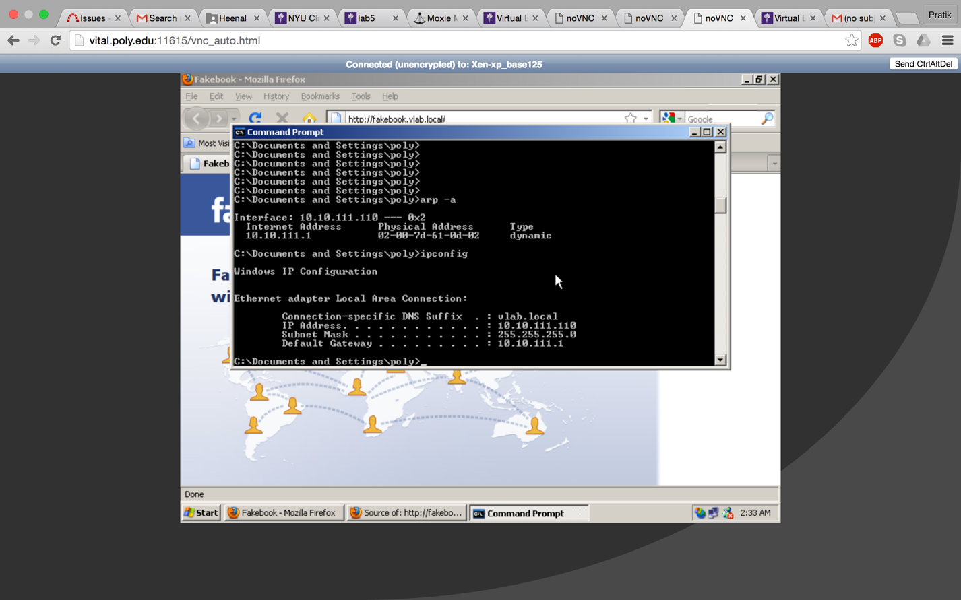

Now on the Backtrack5 machine, we first have to setup up the machine to accept packets inbound and forward them outbound and vice versa. Use command:

**echo "1" > /proc/sys/net/ipv4/ip_forward**

Next we need to modify is IPTables. IPTables is a firewalling application available in Linux distributions. IPtables is taking traffic coming inbound to the Backtrack5 machine which is destined to port 80 (HTTP Web) and redirecting only that traffic to the SSLStrip application which in turn is listening on port 8080. Use command

**iptables -t nat -A PREROUTING -p tcp --destination-port 80 -j REDIRECT --to-port 8080**

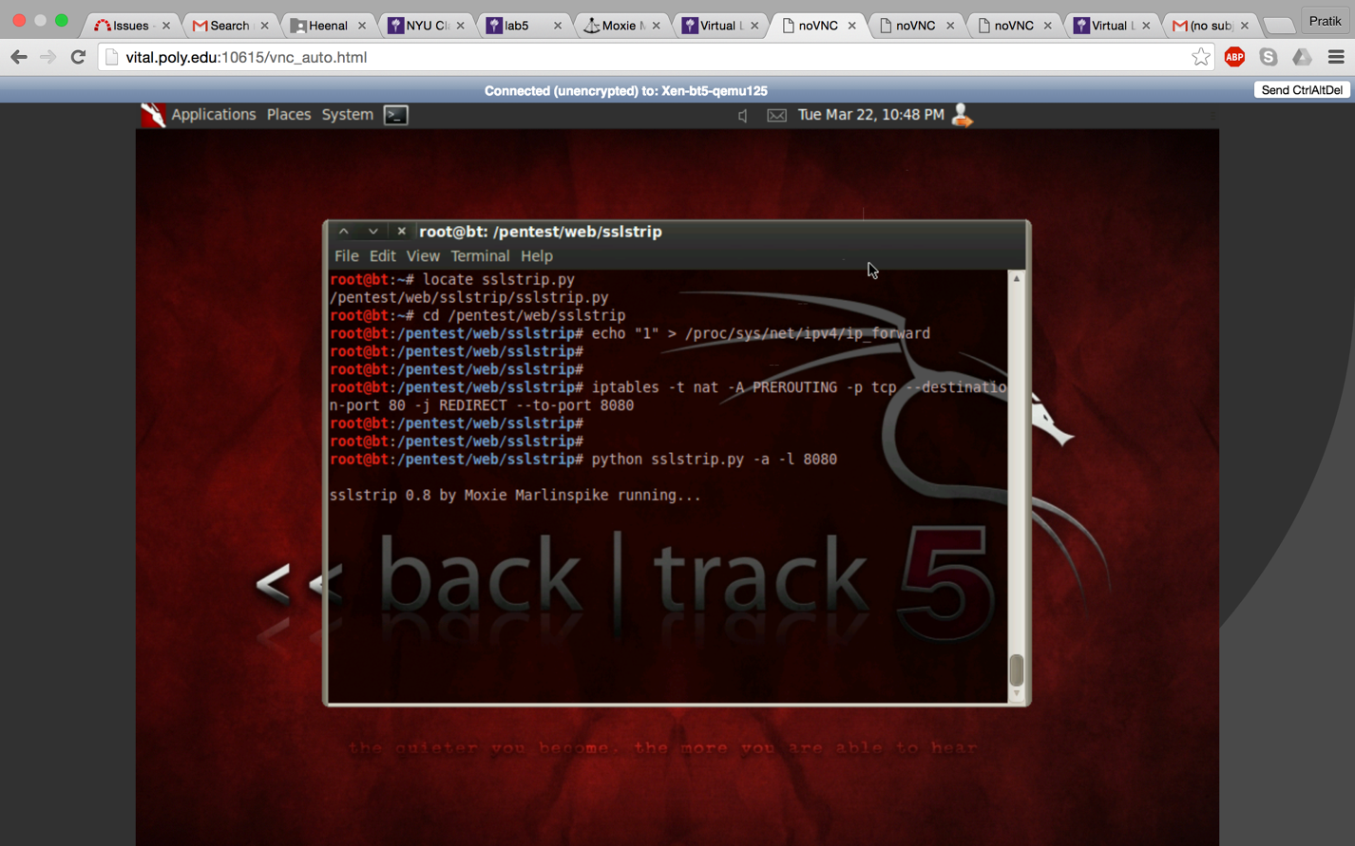

**ARPSPOOFING**

ARP spoofing, also known as ‘ARP cache poisoning’ is a type of attack in which the attacker convinces victim that his MAC address is the router’s MAC address. This is done by constantly sending the victims machine arp replies with the IP of the default gateway mapped to the MAC of the attacker’s machine. In some time the victim machine will believe the attacker and make an incorrect entry in his ARP cache by mapping the attacker’s MAC address against the IP of the default gateway. Similarly, the attacker will poison the ARP table of the router so that the traffic directed to the victim will go to the attacker. In this step, the router’s arp table will be poisoned such that the IP of the victim’s machine will be mapped to the MAC of the attacker’s machine. Hence, the traffic directed to the victim now goes to the attacker. Thus, a Man in the Middle (MITM) attack is initiated and the traffic will now pass through the attacker.

The syntax is as under:

arpspoof [-i interface] [-t target] host :

-i interface: interface to be used (if not mentioned then eth0).

-t target: Host whose ARP will be poisoned (if not mentioned then all hosts on the LAN).

host: Host whose packets we wish to intercept (normally local gateway).

The commands that we use for our lab are as follows:

arpspoof–t 10.10.111.110 10.10.111.1

The above command poisons the ARP table of the victim’s machine (i.e. the XP machine.)

arpspoof –t 10.10.111.1 10.10.111.110

The above command will poison the ARP table of the router.

The attack is as shown below: 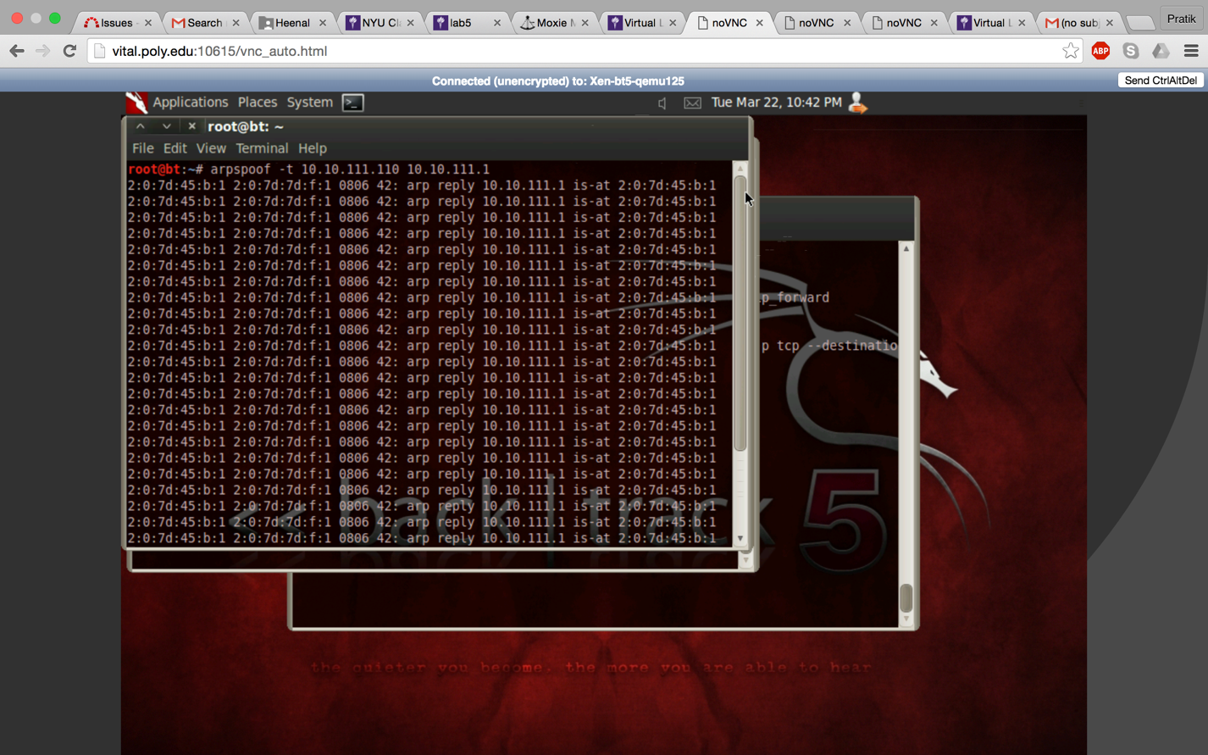

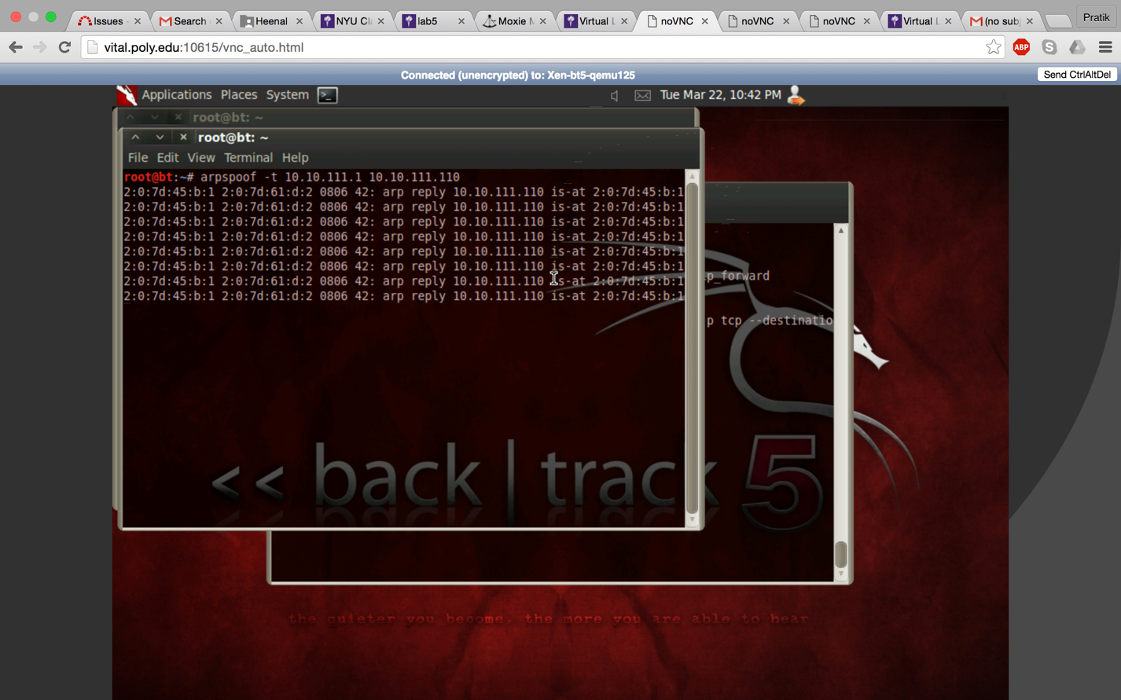

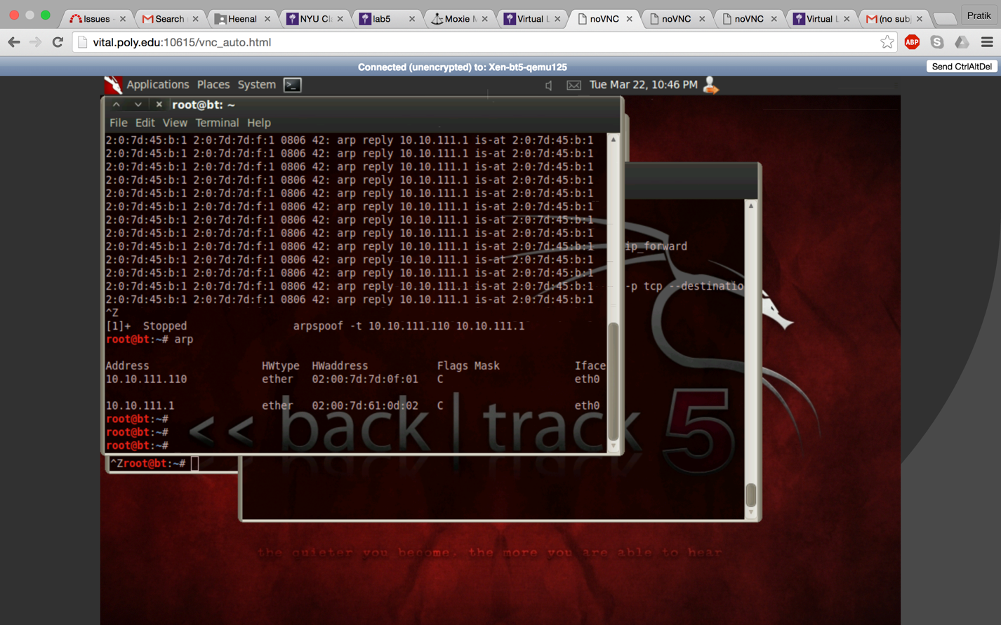

Arp cache of victim after arpspoofing.

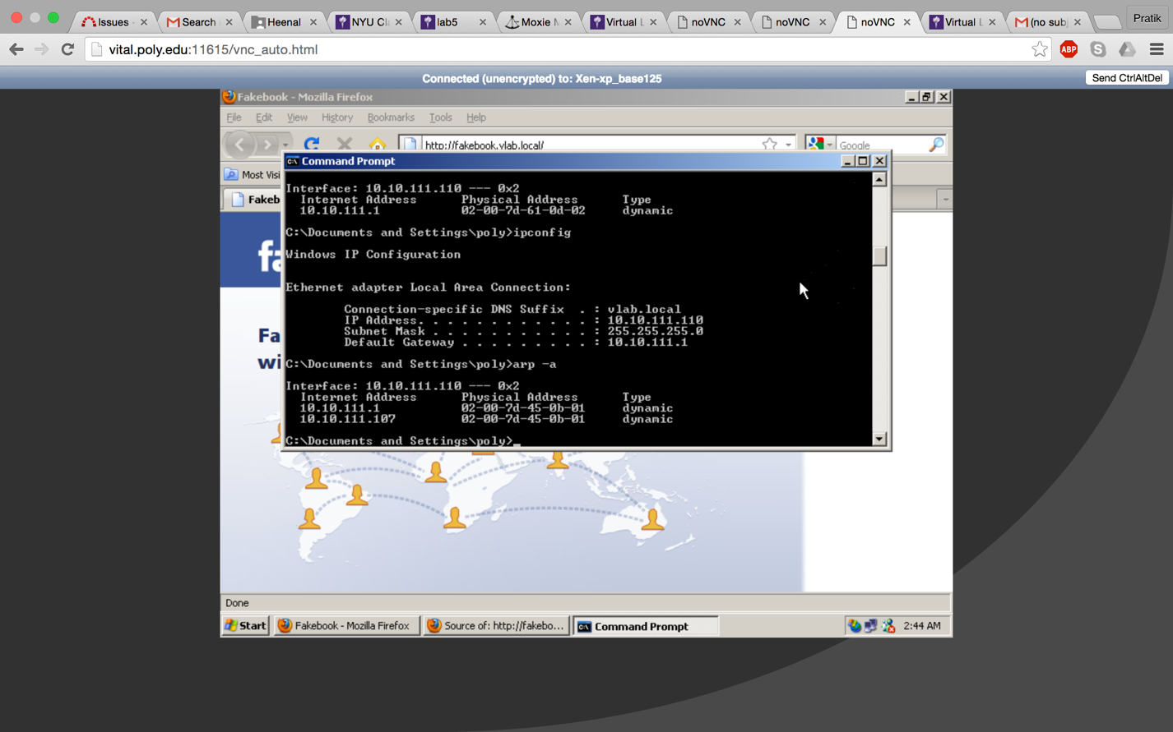

**SSLstrip Attack**

To perform sslstrip attack we perform arpspoofing while running the sslstrip. I have already found the path for sslstrip.py using command: **locate sslstrip.py** so now to run sslstrip I used the command: **python sslstrip.py –a –l 8080.** This starts sslstrip with it listening on port 8080 of the backtrack5 machine

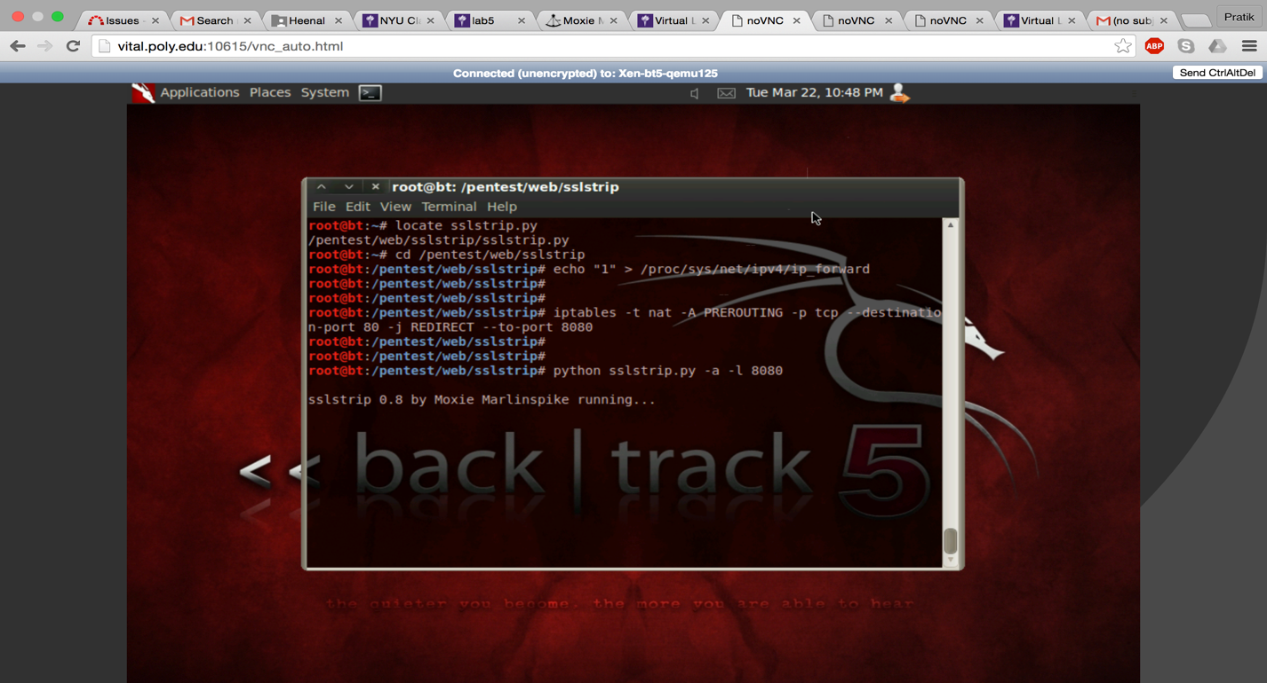

Now we go back to the victim machine and browse Firefox. Again, we click on “view page source”. Record the FORM statement. It is observed that earlier in the form statement before the attack we had **“https”** in the FORM statement. Now it has changed to “**http**” in the FORM field of the login method. Hence it can be concluded that it is unsecure.

From the victim’s machine we login to the fakebook using credentials – username: memon password: evilproffy

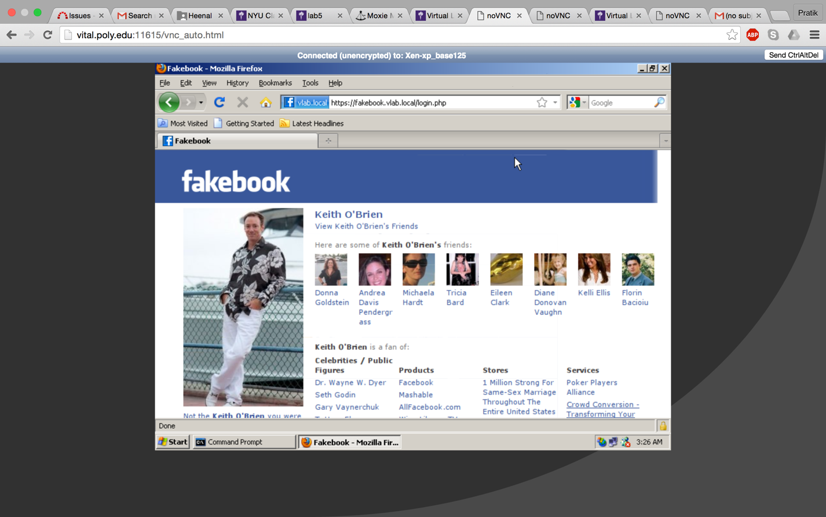

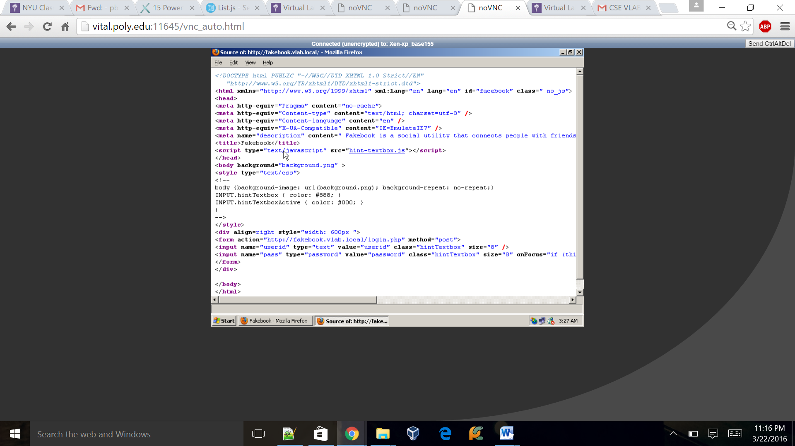

Use command: **cat sslstrip.log** to view the captured login and password details.

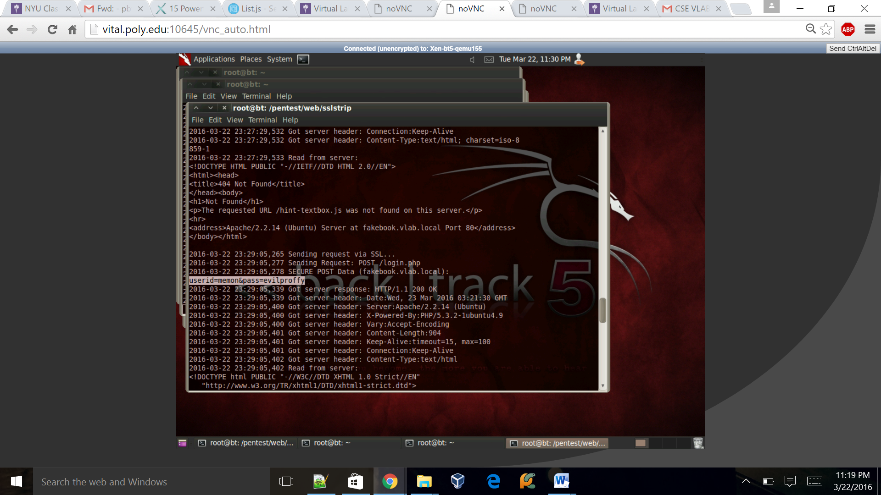

It can be seen that the login credentials **username: memon and password: evilproffy** are captured.

Working of SSLstrip:

The tool SSLstrip is based around the man in the middle attack. By attacking as the man in the middle, the attacker can compromise any information sent between the user (victim) and the apparently secure page. In this Man in the middle (MITM) attack, the attacker will convert every packet coming from the victim, from https to http. Hence the attacker can read the packet and forward it as https to the server. To the server, everything appears secure since it is unaware of the exchange between the victim and the client. Thus, the server won’t detect any problem and the victim will also ignore small changes taking place on the browser.

***References:***

<http://www.irongeek.com/i.php?page=security/arpspoof>

<http://www.thoughtcrime.org/software/sslstrip/>